# week two progress report

|  |  |
| --- | --- |
| Tasks | Progress |
| 1.showing the correct emoji score while user launching the app | Almost done |
| 2.find emoji images | finished |
|  |  |

Task1:

Currently, the app can display scores on screen. But there are too many decimal digits. It causes scores out of bound. Also, the layout need to be improved on. I chose the scroll view. But it seems does not work very well.

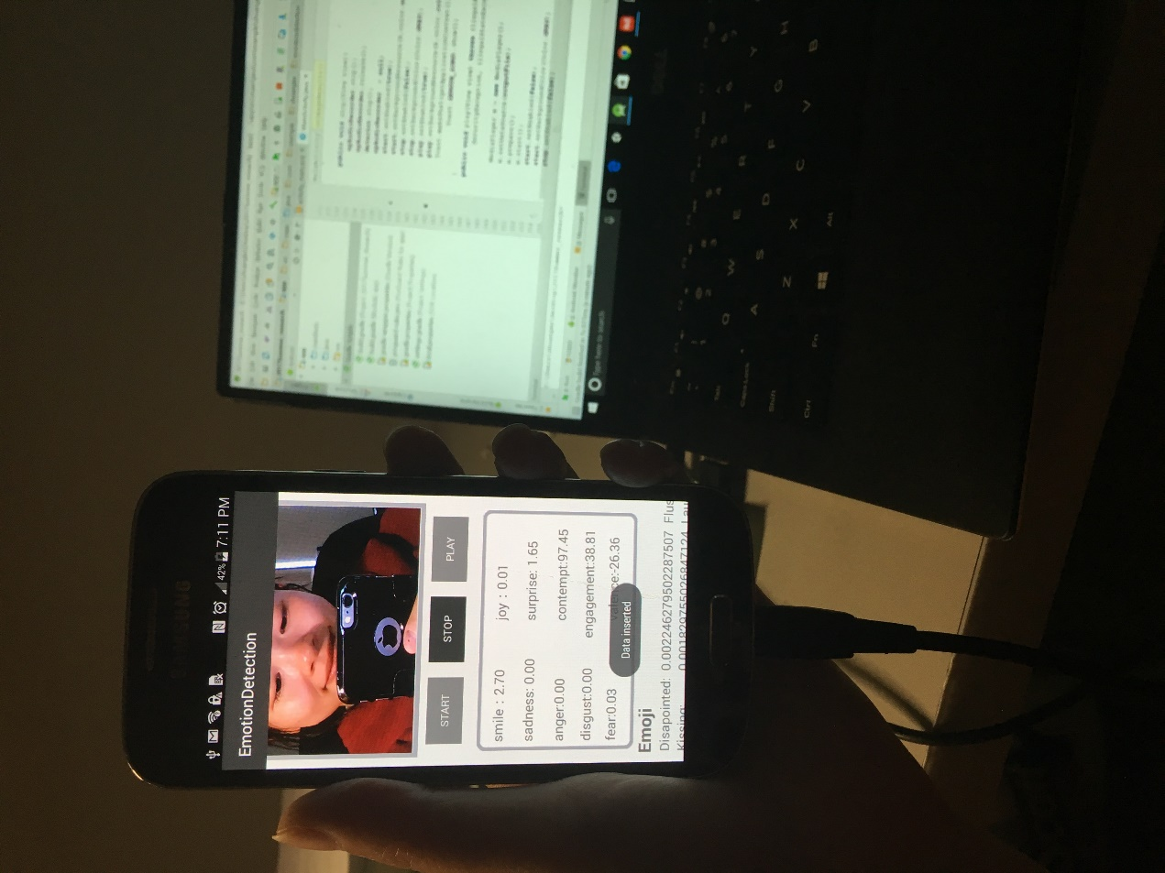

Task2:

I searched some corresponding emoji images in future use.

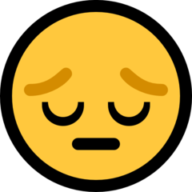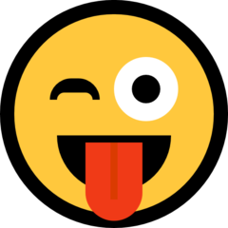

Disappointed stuck out of tongue stuck out of tongue with winking eye

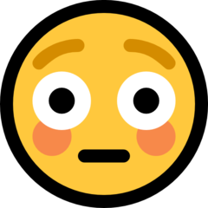

Flushed kissing laughing

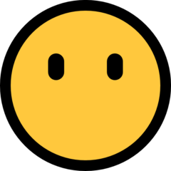

Rage relaxed screaming

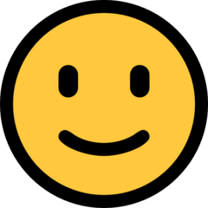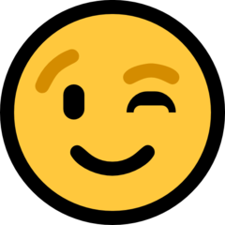

Smile smirk winking